Second Sunday of Advent

~ December 7, 2025 ~

First Lutheran Church, Meadowlands, MN

Prelude

Welcome & Announcements

Lighting of the Advent Wreath
“There was a man sent from God whose name was John. He came
to bear witness to the coming of the light so that all might believe through him”. (John 1:6-7)
O God, help us to be ready for the coming of your Son, the light of all who love him, by making room for him in our hearts. Amen.

Song “Peace, Peace, Peace” (Tune: Still, Still, Still)
Peace, peace, peace – The gift of Christ is peace.
We walk with God, our past forgiven. All in Him is life and heaven.
Peace, peace, peace – The gift of Christ is peace.

Confession and Forgiveness ELW pg. 94

Gathering Hymn “Hark, the Glad Sound!”
ELW #239

Greeting ELW pg. 138

Kyrie ELW pg. 138

Hymn of Praise ELW pg.138

Prayer of the Day Celebrate Insert

First Reading: Isaiah 11:1-10 Celebrate Insert

Psalm: Psalm 72:1-7, 18-19 Celebrate Insert

Second Lesson: Romans 15:4-13 Celebrate Insert
Gospel Acclamation ELW pg. 142

Gospel: Matthew 3:1-12 Celebrate Insert

Sermon

Hymn of the Day
“On Jordan’s Bank the Baptist’s Cry” Vs. 1-4
ELW #249

Apostles’ Creed ELW pg. 105

Prayers of the People Celebrate Insert
“Lord, Listen to Your Children Praying”
ELW #752

Peace

Offering “We Give Thee but Thine Own” vs. 1
ELW #686

Offering Prayer

Great Thanksgiving ELW pg. 145

Words of Institution

Lord’s Prayer ELW pg. 145

Communion

Post Communion Blessing

Prayer after Communion

Blessing

Sending Hymn “Prepare the Royal Highway”
ELW #264

Dismissal
L: Go in peace. Christ is coming soon!
C: We will! Thanks be to God!

Postlude

SALT Parish
South Arrowhead Lutherans Together

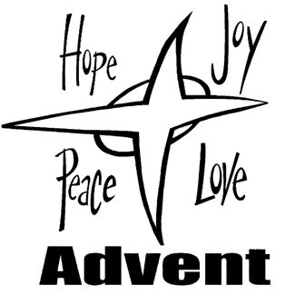

Faith Lutheran Church,
5697 Hwy. 7, Culver, 55779
First Lutheran Church,
9988 Elm St, Meadowlands, 55765
St. John's Lutheran Church,
4893 Independence Rd, Saginaw, 55779
St. Peter's Lutheran Church,
7260 Highway 53 N, Canyon, 55717

David Erdmann, Minister 218-391-7951
Web Site: saltparish.org
Facebook: SALT Parish

